**Lab Report Submission 1**

**Advanced Robotics 11479**

Pranav Dwivedi

u3240814

**Project Name Laboratory Work 1 | Advanced Robotics | u3240814**

**Purpose/Objective(s):**

In this lab we have to familiarise ourselves with Solidworks' environment and capabilities. Create a 3D model of a pressure plate and its technical drawing. Develop a foundation in Solidworks' functionality and gain hands-on experience in pressure plate modelling and technical drawing creation.

**Hypothesis:**

The expected result will be the 3D model of a pressure plate as depicted below:

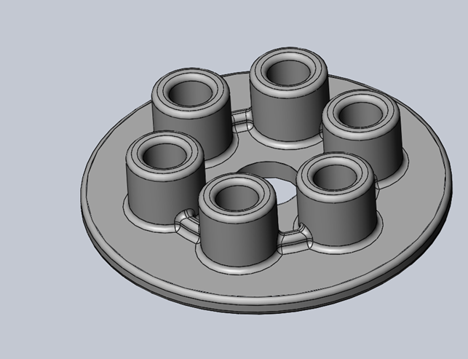

**Materials:**

* SOLIDWORKS
* SOLIDWORKS Tutorials

**Procedure:**

* Pressure plate was the only part created for this model.
* Parts are designed in millimetres for each section.
* Sketching, Fillet, Trim Entities, Extruded Cut, and Extrude Boss/Base are used in designing parts.

The parts are constructed using the guide depicted here:

[Laboratory Work-1](https://uclearn.canberra.edu.au/courses/16396/modules/items/1270983). This guide instructs us to accomplish the introduction to SOLIDWORKS

Tutorial.

**Tabulated Data:**

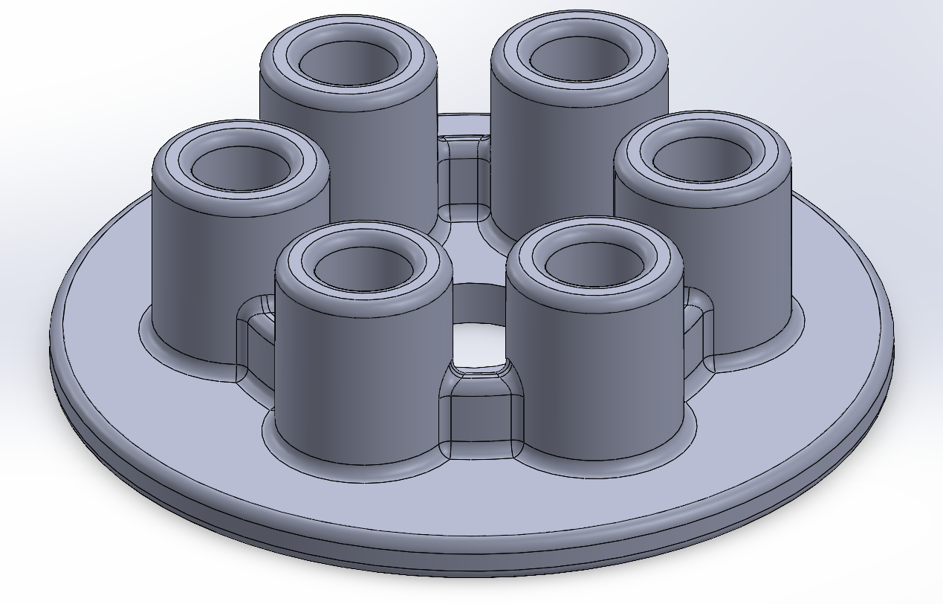

**Drawing:**

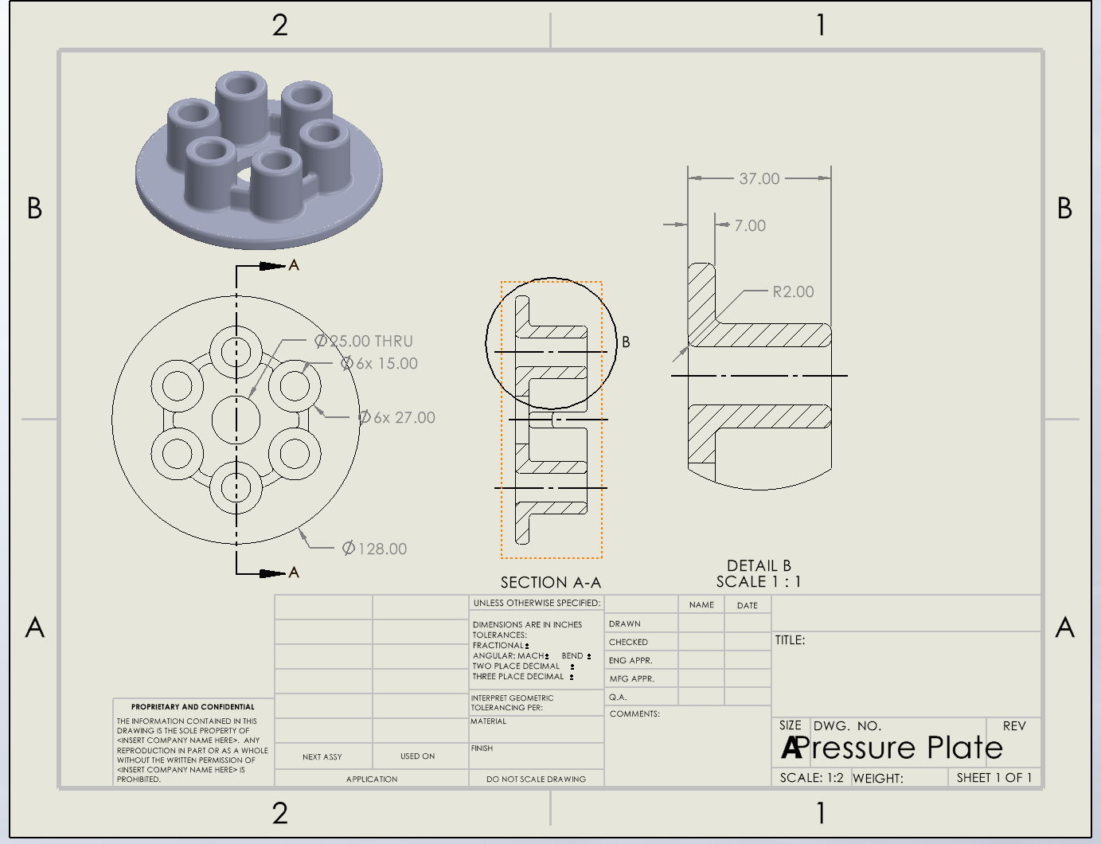

**Analysis:**

This introductory lab provided a useful overview of Solidworks, guiding us through key components and processes involved in creating parts and technical drawings within the software. However, some steps in the tutorial seemed inconsistent with the current version of the tool, particularly regarding the user interface layout rather than the fundamental concepts.

**Conclusion:**

This lab was mainly to familiarise ourselves with Solidworks. We achieved this by designing a pressure plate and creating its corresponding technical drawing. The focus was on understanding the overall layout of the user interface and learning the step-by-step methodologies for creating a technical drawing of the constructed part. Through this lab, we gained valuable insights into the capabilities and functionalities of Solidworks, which will be essential for future design and engineering projects.

**Project Name Lab Work: Lab 2 | Advanced Robotics | u3240814**

**Purpose/Objective(s):**

The objective of this lab is to construct a 3D model of a knuckle joint. This joint facilitates the connection between two cylindrical rods whose axes are situated on the same plane and are subjected to tensile load.

**Hypothesis:**

The expected result will be the 3D model of a knuckle joint as depicted below:

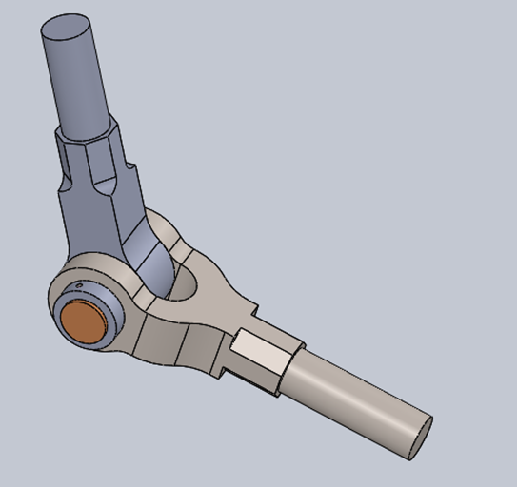

**Materials:**

* SOLIDWORKS

**Procedure:**

* To create the knuckle joint model, five parts are designed in centimetres: Eye End, Fork End, Knuckle Pin, Collar, and Lock Pin.
* Each part requires techniques like sketching, fillet, trim entities, extruded cut, extrude boss/base.

The parts are constructed using the guide depicted here: [Laboratory Work-2](https://uclearn.canberra.edu.au/courses/16396/modules/items/1270986)

**Tabulated Data:**

|  |  |  |
| --- | --- | --- |
| **Step** | **Part Name** | **Part Image** |
| Part-1 | One Eye End |  |
| Part-2 | Fork End |  |
| Part-3 | Knuckle Pin |  |
| Part-4 | Collar |  |
| Part-5 | Taper Pin |  |
| Assembly |  | |

**Analysis:**

Among the many steps requiring careful attention throughout the process, the final assembly of all the components presented the greatest challenge.

**Conclusion:**

This lab was focused on creating a 3D model of a knuckle joint. This specific joint serves the purpose of connecting two cylindrical rods whose axes lie on the same plane. From this lab, the key lesson learned was the procedure involved in assembling the various components after they had been successfully created.

**Project Name Lab Work: Lab 3 | Advanced Robotics | u3240814**

**Purpose/Objective(s):**

In this lab, our objective is to design and construct a 3D model of a universal joint. This joint plays a vital role in transmitting rotational motion between two shafts that are not perfectly aligned.

**Hypothesis:**

The expected result will be the 3D model of a universal joint as depicted below:

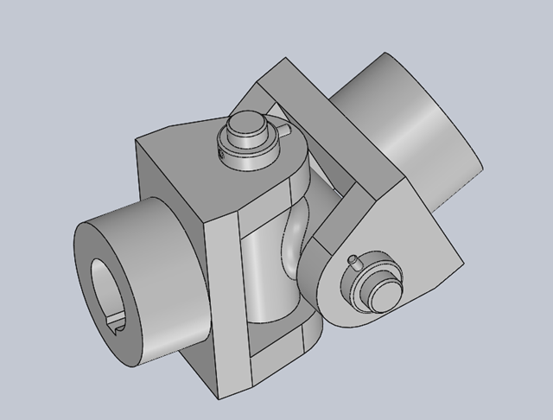

**Materials:**

* SOLIDWORKS

**Procedure:**

* The universal joint model is assembled from five parts: Eye End, Cross Bearing, Bolt, Ring, and Pin.
* Each part is designed in centimetres using techniques like Sketching, Fillet, Trim Entities, Extruded Cut, Extruded Boss/Base, and Chamfer.

The parts are constructed using the guide depicted here: [Laboratory Work-3](https://uclearn.canberra.edu.au/courses/16396/modules/items/1270987)

**Tabulated Data:**

|  |  |  |
| --- | --- | --- |
| **Step** | **Part Name** | **Part Image** |
| Part-1 | One Eye End |  |
| Part-2 | Cross Bearing |  |
| Part-3 | Bolt |  |
| Part-4 | Bolt Collar |  |
| Part-5 | Bolt Taper Pin |  |
| Assembly | Universal Joint |  |

**Analysis:**

Important note during this lab was to maintain the sketch's alignment at the centre. Otherwise, it may result in errors when converting the sketch into an object through the extrude boss/base mirroring around the origin.

**Conclusion:**

This lab aimed at making a 3D model of a universal joint. This type of joint facilitates rotational motion between marginally misaligned shafts. The learning outcomes for this lab included the assembly of individual parts after their creation and the proficiency in rotating those parts.

**Project Name Lab Work: Lab 4 | Advanced Robotics | u3240814**

**Purpose/Objective(s):**

The aim of this lab is to design a 3D model of a robot gripper. Robot grippers serve as the physical connection between a robotic arm and the workpiece. They enable robotic devices to engage with their surroundings in a designated workspace.

**Hypothesis:**

The expected result will be the 3D model of a robot gripper as depicted below:

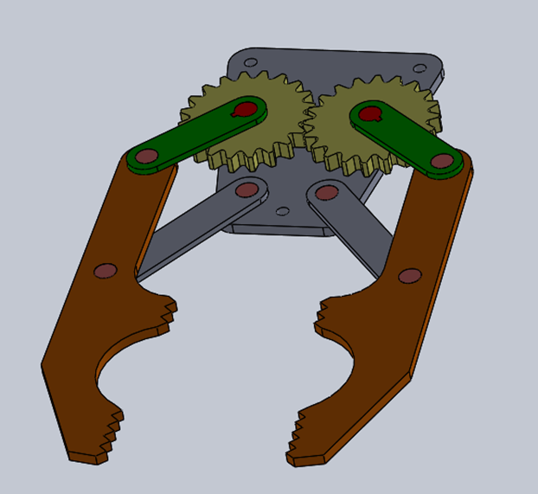

**Materials:**

* SOLIDWORKS

**Procedure:**

* To construct this gripper model, six distinct components must be created and assembled: Holding Plate, Long Arm, Simple Gear, Claw, Pin, and Short Arm.
* Each section's parts are designed in centimeters as the unit of measurement.
* The design process for each component involves utilizing various techniques such as Sketching, Fillet, Trim Entities, Extruded Cut, Extruded Boss/Base, and Chamfer.

The parts are constructed using the guide depicted here: [Laboratory Work-4](https://uclearn.canberra.edu.au/courses/16396/modules/items/1270990)

**Tabulated Data:**

|  |  |  |
| --- | --- | --- |
| **Step** | **Part Name** | **Part Image** |
| Part-1 | Holding Plate |  |
| Part-2 | Long Arm |  |
| Part-3 | Simple Gear |  |
| Part-4 | Claw |  |
| Part-5 | Pin |  |
| Part-6 | Short Arm |  |
| Assembly | Robotic Grippers |  |

**Analysis:**

The trickiest part of this lab was making the claw section. This required the implementation of certain techniques, like using the line tool to draw an arc and employing the Smart Dimension tool to set different specified angles instead of lengths.

**Conclusion:**

This lab was all about designing a 3D model of a robot gripper using Solidworks. These Robot grippers facilitate interaction between robotic mechanisms and their surrounding environment within a specific workspace. The primary learning outcome of this lab was centred around mastering new sketching techniques.

**Project Name: Design of a 4 DOF Robotic Manipulator for Pick and Place Tasks**

**Lab Work: Lab 5 | Advanced Robotics | u3240814**

**Purpose/Objective(s)**

The purpose of this lab is to create a robotic manipulator with four degrees of freedom (DOF) and a gripper. This manipulator should be able to perform pick-and-place tasks within its designated workspace.

Here are the key functions of the manipulator:

* Carry objects from one location to another.
* Lift objects to alter their position.
* Manipulate objects while they are in transit.

**Hypothesis**

The 4 DOF robotic manipulator will perform pick and place tasks within a 1-meter cylindrical workspace. It will lift and manipulate objects up to 1 kg, with a total weight under 30 kg. The aluminium construction and DC motors provide strength, low weight, and smooth movements.

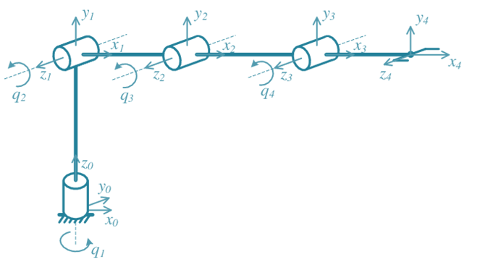

**Specifications**

* **Scope:** Stationary manipulator mounted on a table
* **Material:** Aluminium
* **Degrees of Freedom:** 4 DOF (excluding gripper)
* **Actuators:** DC electric motors
* **Weight Limit:** Not to exceed 30 kg

**Workspace:**

* Reach objects placed within 1 metre
* Cover vertical space above the platform

**Materials**

* SOLIDWORKS software
* DC electric motors

**Procedure**

* Use SOLIDWORKS to design manipulator structure.
* Select suitable DC motors for actuation.
* Create detailed 3D models for each component.
* Assemble components to form the manipulator.
* Verify design meets workspace and weight requirements.
* Document dimensions, features, and motor attachment methods.

**Tabulated Data:**

|  |  |  |
| --- | --- | --- |
| **Step** | **Part Name** | **Part Image** |
| Part-1 | Base |  |
| Part-2 | Link 1-Shoulder Joint |  |
| Part-2 | Link 2-Elbow Joint |  |
| Part-3 | Link 3-Wrist |  |
| Part-4 | End Effector |  |
| Assembly | Robotic Manipulator |  |

**Analysis**

* The manipulator's weight, well within the 30 kg limit, allows for the inclusion of additional components or future modifications while maintaining safety.
* The strategic use of aluminium ensures an exceptional strength-to-weight ratio, contributing to the manipulator's lightweight and rigidity, enhancing its mobility and stability.
* The carefully chosen RRRR configuration grants the manipulator an extensive range of motion and flexibility, making it versatile in object manipulation tasks.
* The selection of DC motors offer a balanced combination of torque, speed, and weight, optimizing the manipulator's performance while minimizing its overall weight.

**Conclusion**

By designing and analysing a 4-DOF robotic manipulator specifically suited for pick-and-place tasks through comprehensive analysis ensuring that the manipulator fulfilled the specified requirements effectively, we were able to gain valuable insights into component selection and design optimization, which are essential considerations in robotics. The successful design of the manipulator not only serves as a strong foundation for future development but also presents opportunities for various applications in the realm of robotics.

**References:**

1. [Laboratory Work 1](https://uclearn.canberra.edu.au/courses/16396/modules/items/1270983)
2. [Laboratory Work 2](https://uclearn.canberra.edu.au/courses/16396/modules/items/1270986)
3. [Laboratory Work 3](https://uclearn.canberra.edu.au/courses/16396/modules/items/1270987)
4. [Laboratory Work 4](https://uclearn.canberra.edu.au/courses/16396/modules/items/1270990)
5. [Laboratory Work 5 Rev1](https://uclearn.canberra.edu.au/courses/16396/modules/items/1270993)
6. [Sample lab report 1](https://uclearn.canberra.edu.au/courses/16396/modules/items/1270995)